
USN | 1 | M | S

(Autonomous Institute, Affiliated to VTU)
(Approved by AICTE, New Delhi & Govt. of Karnataka)
Accredited by NBA & NAAC with ‘A+’ Grade

SEMESTER END EXAMINATIONS – MARCH 2022
Program | : | B.E. : Computer Science and Engineering | Semester | : | V
Course Name | : | Data Mining | Max. Marks | : | 100
Course Code | : | CSE01(O) | Duration | : | 3 Hrs

Instructions to the Candidates:
- Answer one full question from each unit.

 |  | UNIT- I
1. | a) | Explain KDD process with a neat diagram. | CO1 | (05)
 | b) | List and explain data mining issues. | CO1 | (05)
 | c) | Generate three frequent itemset for the given database using AprioriTid algorithm. {Consider support count as 3}. | CO1 | (10)
  Transaction Id | Items
  1 | R, S
  2 | U
  3 | P, R
  4 | R, S, U
  5 | Q, R, U
  6 | S, U, V
  7 | P
  8 | P, R, S
  9 | R, S, U, V
  10 | S, T
  11 | Q, S
  12 | S, V
  13 | T, U
  14 | R, S, U
2. | a) | Explain any five functionalities of data mining. | CO1 | (08)
 | b) | The data for analysis include the attribute rank. The rank values for the data tuples are (in ascending order)  X = {1, 1, 1, 1, 1, 2, 2, 11, 11, 12, 12, 44}.  Apply Equal width binning and Equal frequency binning on the above set. | CO1 | (06)
 | c) | Explain with examples the different transformation techniques used on data to be mined. | CO1 | (06)
 |  | UNIT – II
3. | a) | Define Classification. Explain two-step process of classification. | CO2 | (06)
 | b) | For the data set given below, calculate Information gain for the attribute “age”. | CO2 | (08)
  age | Income | Student | credit_  rating | buys_  computer
  <=30 | High | No | Fair | No
  <=30 | High | No | excellent | No
  31…40 | High | No | Fair | Yes
  >40 | medium | No | Fair | Yes
  >40 | low | Yes | Fair | Yes
  >40 | low | Yes | excellent | No
  31…40 | low | Yes | excellent | Yes
  <=30 | medium | No | Fair | No
  <=30 | low | Yes | Fair | Yes
  >40 | medium | Yes | Fair | Yes
  <=30 | medium | Yes | excellent | Yes
  31…40 | medium | No | excellent | Yes
  31…40 | high | Yes | Fair | Yes
  >40 | medium | No | excellent | No
 | c) | Define minimum support and minimum confidence. Write the apriori algorithm for frequent item set mining. | CO2 | (06)
4. | a) | Consider the following dataset.  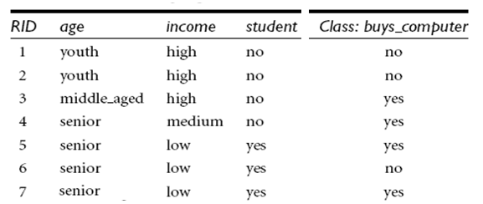  Given a new data tuple with age = “senior“, income = “low“ and  student = “ yes ” classify the data tuple using naïve Bayesian classifiers. | CO2 | (08)
 | b) | Explain with an example to show that items in a strong association rule actually may be negatively correlated and how can it be handled. | CO2 | (06)
 | c) | For the dataset given below, show the LItemset phase and Transformation phase for mining sequential patterns. Consider minimum support to be 2. | CO2 | (06)
  Customer  ID | Transaction  Time | Items  Bought
  1 | June 25 '93 | 30
  1 | June 30 '93 | 90
  2 | June 10 '93 | 10,20
  2 | June 15 '93 | 30
  2 | June 20 '93 | 40,60,70
  3 | June 25 '93 | 30,50,70
  4 | June 25 '93 | 30
  4 | June 30 '93 | 40,70
  4 | July 25 '93 | 90
  5 | June 12 '93 | 90
 |  | UNIT – III
5. | a) | Explain the KNN algorithm for classification. | CO3 | (06)
 | b) | Explain support vector machine with an example. | CO3 | (06)
 | c) | Consider the neural network shown below. Let the learning rate be 0.9. The initial weight and bias values of the network are given, along with the first training tuple, X = (1, 0, 1), whose class label is 1. Calculate the error values, weight and bias updates using back propagation.  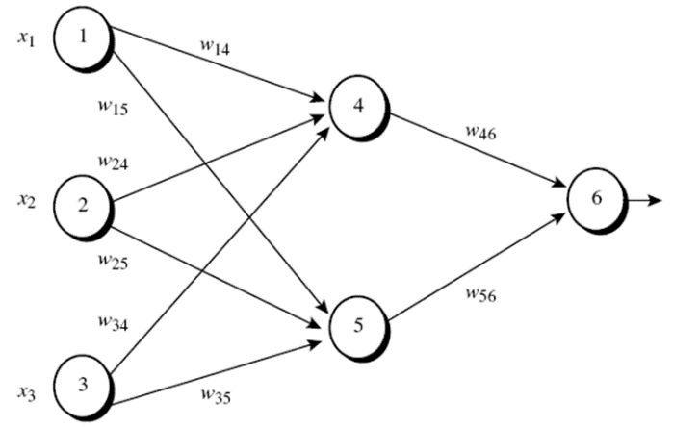  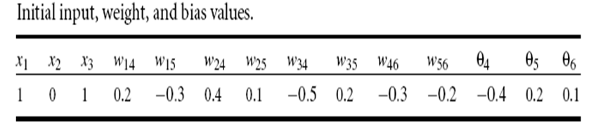 | CO3 | (08)
6. | a) | Explain C4.5 algorithm. | CO3 | (06)
 | b) | Consider the following data set for salary data. Predict the salary of a graduate with 20 years of experience using straight linear regression. | CO3 | (06)
  X years experience | Y salary (in $1000)
  8 | 35
  13 | 62
  14 | 69
  18 | 77
  8 | 41
  11 | 48
  16 | 64
  26 | 95
  6 | 25
  21 | 88
 | c) | Explain classification by backpropagation. | CO3 | (08)
 |  | UNIT – IV
7. | a) | Consider the following database with mixed data type attributes. Calculate the dissimilarity matrix obtained for the data described by all the three attributes individually and then calculate the dissimilarity matrix using all the three attributes together.  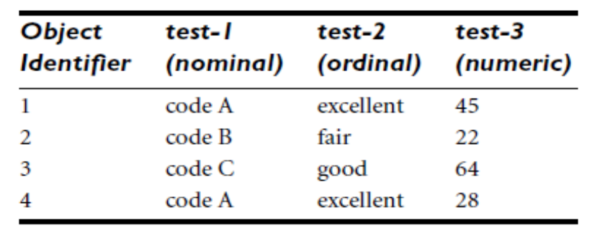 | CO4 | (08)
 | b) | Explain agglomerative hierarchical clustering method. | CO4 | (06)
 | c) | Differentiate between K-means and K- mediods clustering methods with an example. | CO4 | (06)
8. | a) | Explain the following clustering methods:  - DIANA ii. CLIQUE. | CO4 | (06)
 | b) | Explain DBSCAN. How does DBSCAN find clusters? | CO4 | (08)
 | c) | Define clustering. Explain general characteristics of categorization of major clustering methods. | CO4 | (06)
 |  | UNIT – V
9. | a) | Explain the working of Google page rank algorithm and damping factor. | CO5 | (05)
 | b) | Explain the following:  - Web mining  - Usage mining  - Link mining  - Statistical relational learning  - Web content mining. | CO5 | (10)
 | c) | Illustrate how using ensemble methods can lead to increased accuracy. | CO5 | (05)
10. | a) | Explain challenges of Genomic Data mining. | CO5 | (10)
 | b) | Explain the following:  - Mining time series data.  - Text mining. | CO5 | (10)

****************

